QKN1 Task 2: Financial Data Analysis Program Implementation Using Python
Course: Analytics Programming — D598
Student: Dotun Oduwale

Introduction
This project was completed for a small investment company that manages an equity fund consisting of approximately 150 U.S.-based companies operating across multiple states and industries. The purpose of this analysis is to assist fund managers in evaluating recent company performance and supporting informed portfolio rebalancing decisions.
In Task 2, the pseudocode from Task 1 was converted into a functional Python program using a Jupyter Notebook. This program performs the same financial data analysis, including duplicate detection, descriptive statistics, filtering, and ratio calculations. The program has been structured for clarity with headings and comments to enhance readability and ensure easy understanding when uploaded to the WGU GitLab repository.

A. Flowchart
The flowchart from Task 1 is reused here as it represents the logical steps for the Python program. It illustrates the flow from data import to the final concatenated output, including decision points for duplicates and negative Debt-to-Equity ratios.
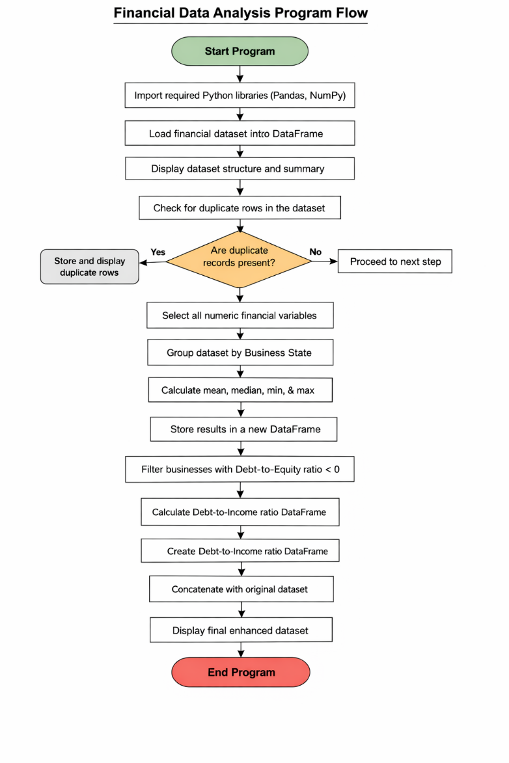

B. Python Program / Code Overview
The Python code follows the same logic as the pseudocode from Task 1. Each major step is implemented with comments and headings in the Jupyter Notebook.
Major Steps:
- Data Import
  - Load the dataset (D598 Data Set.xlsx) into a Pandas DataFrame.
  - Display basic structure and preview of the dataset.
- Duplicate Detection
  - Identify and store any duplicate rows.
  - Output preview of duplicates for verification.
- Grouping and Descriptive Statistics
  - Group businesses by State.
  - Calculate mean, median, min, max for numeric financial columns.
  - Store results in a new DataFrame.
- Filter Negative Debt-to-Equity
  - Identify businesses where the Debt-to-Equity ratio is negative.
  - Display preview of filtered rows.
- Debt-to-Income Ratio Calculation
  - Compute Debt-to-Income as Long-Term Debt / Revenue.
  - Create a new DataFrame for this ratio.
- Concatenation with Original Dataset
  - Combine Debt-to-Income DataFrame with the original dataset.
  - Display final consolidated DataFrame for review.

C. Screenshots / Output Preview
The following screenshots demonstrate the successful execution of the Python program in Jupyter Notebook:
Screenshot 1: Data Import Confirmation (Preview)
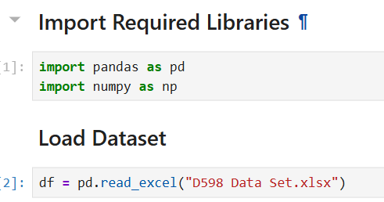
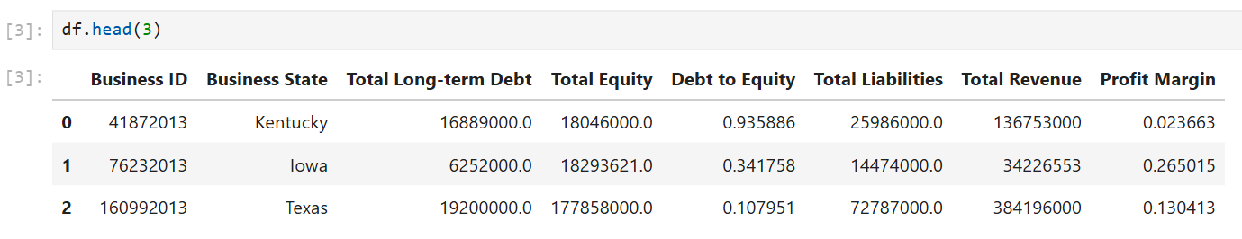
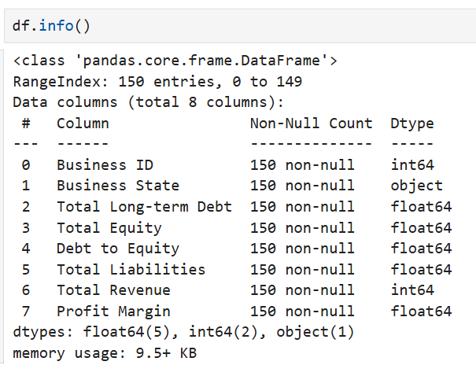
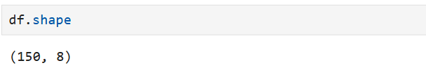

Screenshot 2: Duplicate Rows Identification (Preview)
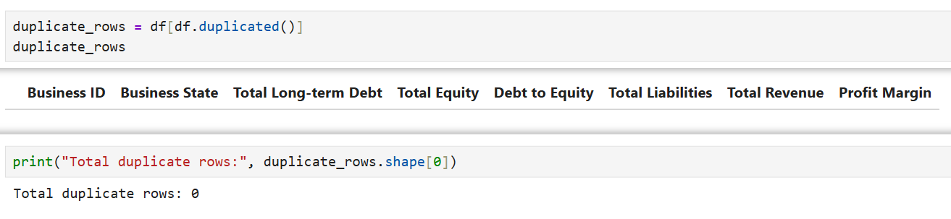
Screenshot 3: Grouped Descriptive Statistics by State (Preview)
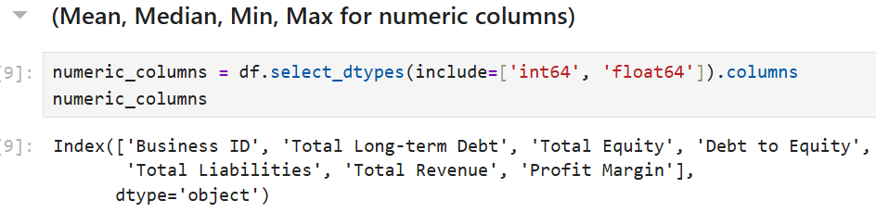
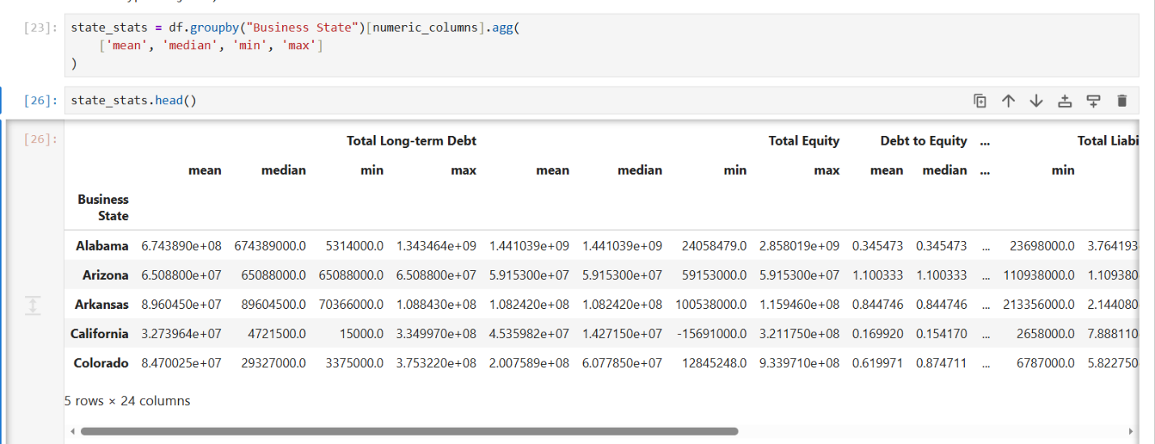

Screenshot 4: Negative Debt-to-Equity Ratio Filter (Preview)
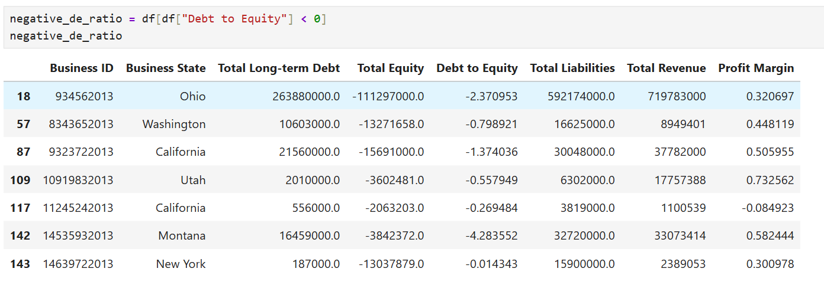
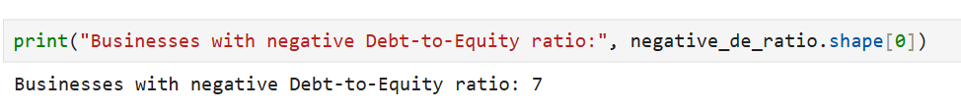
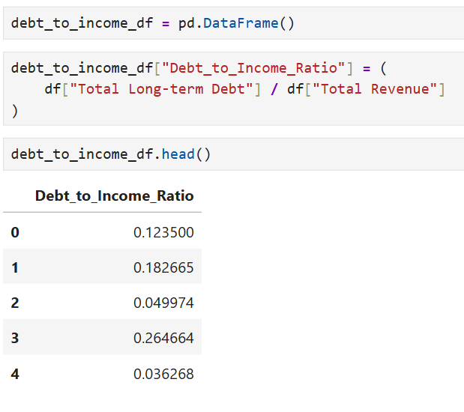
Screenshot 5: Final Concatenated Dataset (Preview)
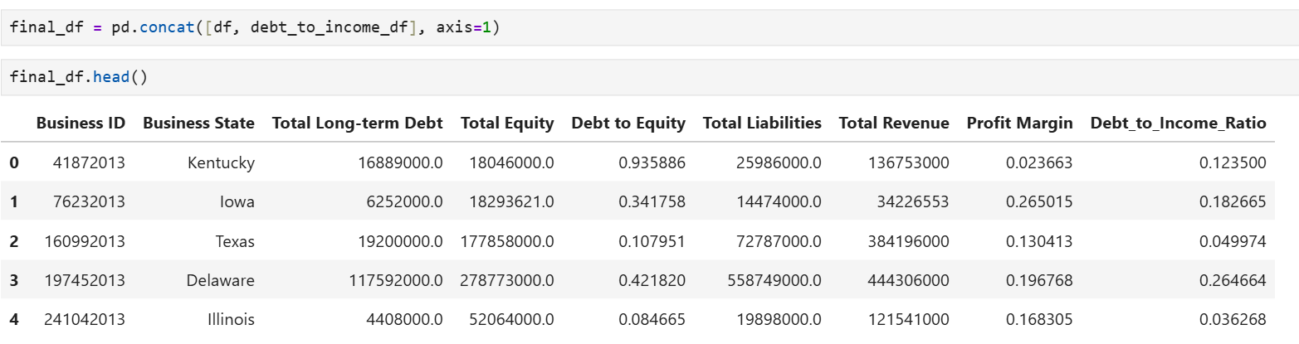

D. Alignment Between Flowchart, Pseudocode, and Python Program
- The flowchart, pseudocode, and Python code are fully aligned.
- Each process in the flowchart corresponds to a code block in the notebook.
- Decision points, such as duplicates detection and filtering negative Debt-to-Equity ratios, are implemented in Python with conditional logic.
- This ensures the visual, algorithmic, and coded steps are consistent.

E. Sources and References (APA Style)
No external sources were used in the development of this project. All program logic, pseudocode, and analysis were created independently based on the concepts learned during the Analytics Programming (D598) course.

F. Professional Communication Statement
This document has been prepared using clear, concise, and professional language appropriate for an academic and business audience. All code comments, headings, and outputs are clearly labeled to facilitate interpretation and validation. Grammar, spelling, and sentence structure have been carefully reviewed for clarity and accuracy.

Appendix (Optional)
- Full Jupyter Notebook is available in the GitLab repository for review if required.

